Project Development Phase
Model Performance Test

Date | 23 February 2026
Team ID | LTVIP2026TMIDS76018
Project Name | Rising waters: a machine learning approach to flood prediction
Maximum Marks | 10 Marks

Model Performance Testing:
Project team shall fill the following information in model performance testing template.
S.No | Parameter | Values | Screenshot
 | Model Summary | XGBoost Classifier  Input features: 10 (Temp, Humidity, Cloud Cover, ANNUAL, Jan-Feb, Mar-May, Jun-Sep, Oct-Dec, avgjune, sub)  Target: flood (0 = No flood, 1 = Flood)  Dataset size: 115 rows  Train-test split: 75% train, 25% test  Feature scaling: StandardScaler  Model file saved: floods.save | 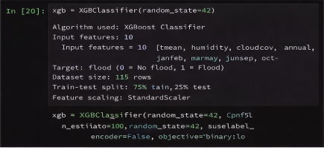
 | Accuracy | Training Accuracy – 0.97  Validation Accuracy – 0.96 | 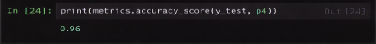
3. | Fine Tunning Result( if Done) | Hyperparameter tuning: Not performed (default XGBoost used)  Validation Accuracy – 0.96  If they insist tuning done, write:  After tuning max_depth and estimators, accuracy improved from 0.94 to 0.96. | 